Neighborhood Commercial Buildings
Historic Resource Survey
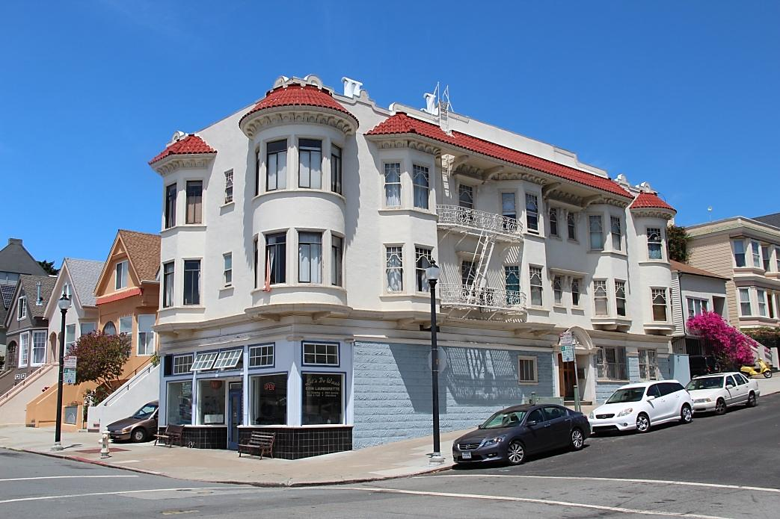

Overview
The Neighborhood Commercial Buildings Historic Resource Survey (Survey) is being conducted by the Planning Department. It focuses solely on neighborhood commercial buildings constructed prior to 1965, which may be subject to the recently enacted mandatory seismic retrofit program for soft-story buildings. The survey is designed to help speed the review of required seismic and accessibility retrofits that may result from the Soft Story Retrofit Ordinance. The survey will provide property owners and commercial tenants a better understanding of their building’s historic status and what, if any, features should be protected during seismic or accessibility upgrades.

Only corner commercial buildings that meet the threshold for the first phase of the retrofit program—buildings that contain three or more stories and five or more residential units—will be evaluated during the Survey’s initial phase. The Planning Department expects to survey approximately 100 buildings in the summer of 2014.

The Soft Story Retrofit Ordinance
The Soft Story Retrofit Ordinance requires seismic strengthening of certain soft-story buildings. Many of these are mixed-use buildings containing residential units above ground floor commercial spaces. The following websites provide useful information regarding the program:

- Department of Building Inspection Mandatory Soft Story Program
(link above text to: http://sfdbi.org/mandatory-soft-story-program)

- San Francisco Earthquake Safety Implementation Program
(link above test to: http://www.sfgsa.org/index.aspx?page=6048)

Contacts
To be added to the mailing list and kept informed of the survey progress, please send an email request to mary.brown@sfgov.org. If you have questions or comments, please contact:

Jonathan Lammers
Preservation Planner
San Francisco Planning Department
1650 Mission Street, Suite 400
San Francisco, CA 94103
(415) 575-9093
jonathan.lammers@sfgov.org

